Explore of Developer Tools:

001: Media Files and also other kinds of files can view under **NETWORK** section.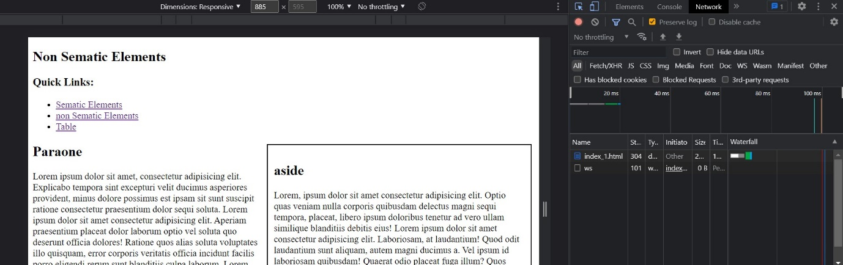

002: Javascript output and error can view in **Console** Section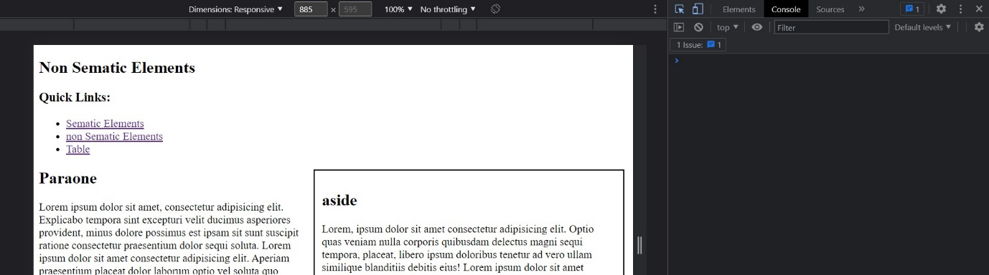

003:We can view our Html Code , DOM Manipulation in **Elements** Section and to see CSS properties is Properly is applied or not in **Styles**.